**KAMPALA PARENTS’ SCHOOL 2004**

**END OF YEAR EXAMINATION, 2018**

**P.2 ENGLISH**

**NAME: ____________________________STREAM:____________DATE:_____________**

**1. Write the following correctly.**

m r o o b - _______________ b y b a - ________________

e e y - __________________ e s t n - _________________

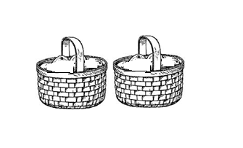

**2.** **Name these pictures.**

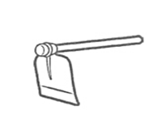

_______________ ________________

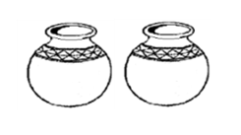

_____________________

**3. Write in words.**

1st __________________ 3rd ___________________

40 ___________________ 5th ____________________

**4. Use the verbs in the brackets correctly.**

a. The cleaner is ___________________ the classroom. (mop)

b. We should always _________________ others. (help)

c. A thief ___________________ our radio yesterday. (steal)

d. John _______________ to school everyday. (go)

e. I am ____________________ well. (write)

**- 2 –**

**5. Write the opposite**

a. strong ________________________ b. smart ___________________

c. rich ___________________

**6**. **Complete correctly.**

a. short __________________ shortest

b. ______________ bigger biggest

c. good better ________________

**7. Show the time.**

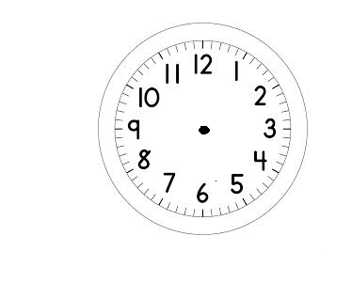

a. b.

It is eight o'clock. It is a half past two o'clock.

**8. Use Yes, I do or No, I do not.**

a. Do you like fighting?

____________________________________________________________________

b. Do you like sharing?

____________________________________________________________________

**9. Choose the correct word from the brackets.**

a. A ______________ gives us eggs. ( dark, duck)

b. May I have four _____________________________ of sugar please?

( litres, kilogrammes)

c. She bought one _________________ of paraffin. (metre, litre)

d. How many ____________________ make a year? ( mouth, months)

e. Zacchaeus was a _________________ collector. (taxi, tax)

**- 3 -**

**10. Match correctly.**

nuns barracks

army men church

prisoner home

parents prison

traders shop

**11. Join sentences using because**

a. He cannot pick the mango . He is short.

____________________________________________________________________

b. I am happy. I passed my exams.

____________________________________________________________________

c. Nadia did not go to church. It was raiing.

____________________________________________________________________

**12. Answer correctly.**

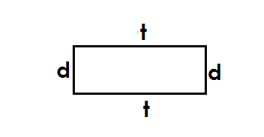

a.

Which side is longer?

Side ______________ is longer than side _____________.

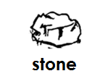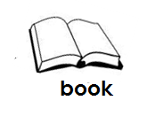

b.

Which is heavier?

The ________________ is heavier than the ________________.

**- 4 –**

**13. Use the words below to complete the sentences.**

**alone groups gifts listen Report**

a. You should ___________________ to your teachers.

b. You should always walk in _________________________.

c. _________________ bad people to your parents.

d. Do not walk __________________ at night.

e. Do not accept ___________________ from strangers.

**14. Read the dialogue and answer the questions.**

Joy : Good morning Bob.

Bob : Good morning Joy.

Joy : Why didn't John come to school on Tuesday?

Bob : John had an accident. He went to see a doctor with

mother yesterday.

Joy : Sorry, what caused the accident?

Bob : He fell off a bicycle when he was riding to town.

a. How many people are talking in the dialogue?

____________________________________________________________________

b. Who is Bob's brother?

____________________________________________________________________

c. On which day did Bob's brother miss school?

____________________________________________________________________

d. How did John get the accident?

____________________________________________________________________

*MERRY CHRISTMAS*